Encinal High School  Athletic Boosters – Board Meeting  Agenda  April 15, 2020 6:30pm - Pier 29 Restaurant | 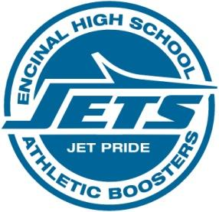

MEETING CANCELED DUE TO COVID-19

Athletic Director’s Report -Lani/Kevin
  - .

Treasurer’s Report - Vince

  - Updates

Crab Feed Debrief - Helene
  - Check in/out
  - Acquisitions
  - Auction Items
  - Set-up/Decor
  - Merchandise.
  - Kitchen
  - Timeline of Event/Flow
  - Event Location
  - Marketing
  - Volunteers
  - Expenses
  - Net Fundraised
  - Other

- Procedure for Coaches requesting funds
  - Clarity & Consistency- Team Holdings vs. AD/Booster purchases
  - Streamline procedure
  - List of Team Guidelines for budgeting purposes of how often each team will be allowed to receive new items/uniforms, etc. from AD/Boosters. (If they fundraise on their own they can get items every year…)
Adjourn

Next Month’s meeting: May 13 2020 at EHS ROOM 605?

