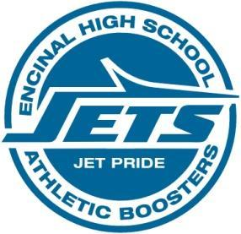
Encinal High School Athletic Boosters
Crab Feed Planning and Board Meeting
December 11, 2017 6:30 PM Pier 29

Agenda
1) Welcome and Introductions
2) Motion Items
Approve minutes from Oct 9, 2017 meeting
Nomination, voting, and approval of Crab Feed Co-chairpersons as Vice President
3) Treasurer’s Report
4) Crab Feed Presentation Sunny Merry and Helene Onaga

- Finalize volunteer committee chairs and their teams
- Create email groups for disseminating information relevant to your volunteer commitment
- Brainstorm re: community support for the event, donations, attendance & sponsor outreach
Please bring one person with you not on this list. More hands = More success (and more fun too!)

5) Athletic Directors’ Report
6) New Business and Discussion Items
a) Instead of Team Baskets, there has been a request to submit a cash donation—minimum value?
b) A few parents prefer to donate cash rather than spend time doing fundraisers
c) Decision on Ticket sales pricing $60 per person, VIP table ?
d) Timeline to go live with ticket sales on website, payments, separate Paypal account for crab feed, board decided unamimously to cancel the crab feed website at last meeting
e) Timeline to submit program ads, live auction, dessert auction, proof program, publish

7) Old Business
Crab Feed Planning ---important date and timelines
  - Deposited $1000, cancellation more than 61 days prior, charge except $15 admin fee
  - Cancellation 60-31 days half of deposit
  - Cancellation 30-15 days entire deposit
  - 2/6/2018 check list due date, insurance, permits, etc. due
  - Event date: Saturday February 24, 2018
Banner Ad and Sponsorship---forms are on front page of website (banner ad logo)

