Encinal High School  Athletic Boosters – Board Meeting  Minutes  January 12, 2017 6:30pm | 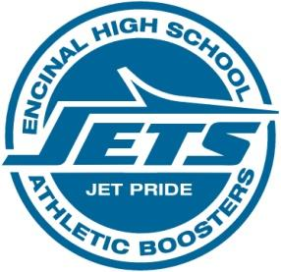

1) Motion Items
Motion 1 Approve Minutes from 11/14/16 Booster meeting
Initial Motion: Dave Skaff
Second: Kris Nelson
All in favor

2) Discussion Items
a. Athletic Packets are now available for online submission. Paper copies are still available for anyone that needs them.

3) Treasurer’s Report
a. WACC fees totaling $11,700 were just paid out

4) Old Business
No old business needed attention

5) New Business
None

6) Crab Feed
All upcoming items were discussed. Scott McKaskill printed all flyers and leaflets.
